COLLEGE NAME: DONBOSCOCLEGE (CO-ED), YELAGIRI HLLS

COLLEGE CODE: 358

DEPARTMENT: DEPARTMENT OF COMPUTER APPLICATIONS

TITLE: Courier Management System (CMS)

TEAM MEMBERS’ NAME:

S.NO | NAME | REGISTER NUMBER
1 | CHARLES ASWIN RAJ L | 35824U09024
2 | DANIEL AUGUSTIN P | 35824U09025
3 | DARVIN S | 35824U09026
4 | DIVAKAR K | 35824U09028
5 | DINALTY JOSHVA A | 35824U09030

ABSTRACT
Courier and delivery services are an important part of modern logistics, where proper management of customers, shipments, delivery agents, branches, and delivery activities plays a crucial role in ensuring efficient and timely parcel delivery. However, many courier organizations still rely on manual methods such as paper records, spreadsheets, or disconnected systems to manage shipment-related information. These traditional methods can result in data inconsistency, record duplication, tracking difficulties, calculation errors, and challenges in maintaining relationships between different records.
The Courier Management System is a cloud-based solution developed using Salesforce to address these challenges. The system is designed to store, manage, and organize courier-related information in a centralized and structured manner. It utilizes custom objects such as Customer, Shipment, Delivery Agent, Branch, Delivery Update, and Invoice, along with Master-Detail and Lookup relationships, to maintain proper relationships between records and support efficient data management.
The application enables users to maintain important information related to customers, shipments, delivery agents, branches, delivery updates, and invoices in an organized manner. Custom fields, relationships, validation rules, and Salesforce automation features help maintain data accuracy and consistency. The system also provides reports and dashboards that allow users to monitor shipment activities, track delivery progress, manage delivery agents, analyze branch performance, and review invoice information efficiently.
By transforming manual courier record-keeping into a centralized, secure, and organized digital system, the Courier Management System improves data accessibility, reduces administrative effort, and supports better management of delivery operations. The project demonstrates how Salesforce CRM technology can be effectively applied to the courier and logistics sector to simplify shipment administration, improve tracking and information management, and support data-driven decision-making.

PROBLEM STATEMENT
In many courier and logistics organizations, especially small and medium-sized businesses, shipment-related information is still maintained manually using notebooks, paper records, spreadsheets, or separate systems. While these methods may work for a small number of shipments, they become highly inefficient as the number of customers, shipments, delivery agents, branches, and invoices increases. Manual systems lack automation and structured data management, which creates several operational challenges.
Some of the major problems faced in traditional courier management systems include:
• Data duplication and inconsistency
• Manual errors in maintaining customer and shipment records
• Difficulty in tracking shipment details and delivery progress
• No centralized database for storing courier information
• Time-consuming report generation
• Limited monitoring and analytical capabilities
Because of these limitations, courier administrators and delivery managers may find it difficult to maintain and access accurate information. Important details such as customer information, shipment records, delivery agent details, branch information, delivery updates, and invoice details often need to be maintained separately, increasing the possibility of missing or inconsistent records. Moreover, managing relationships between customers, shipments, delivery agents, branches, delivery updates, and invoices becomes complicated when information is stored in disconnected files or paper records.
Another significant issue is the lack of real-time insights into shipment and delivery operations. In courier management, timely access to accurate information is important for effective planning and decision-making. However, without automated reports and dashboards, administrators may have difficulty monitoring shipment status, tracking delivery progress, analyzing delivery performance, and reviewing invoice information. This can lead to:
• Delayed shipment management decisions
• Difficulty in monitoring delivery progress
• Inaccurate or incomplete shipment analysis
• Reduced transparency in courier operations
Additionally, traditional systems may not provide proper validation rules, security controls, or role-based access. This can result in unauthorized changes, duplicate records, data loss, or incomplete information. As the volume of courier transactions increases, maintaining historical shipment records and retrieving specific information can also become increasingly difficult.
Therefore, there is a strong need for a centralized, automated, and cloud-based Courier Management System developed using Salesforce. Such a system can provide organized data storage, structured relationships between objects, improved data accuracy, secure access, automated tracking, and effective reporting capabilities. Implementing this solution can improve courier information management, reduce manual effort, simplify shipment and delivery record maintenance, and support better planning and decision-making in courier and logistics operations.
PROPOSED SOLUTION

To overcome the identified challenges, the proposed solution is the development of a
Farm Management System, a cloud-based application developed using Salesforce.
The application is designed to provide a structured, scalable, and organized
environment for managing farm-related information.
Farm Object
This object stores important details about farms such as:
• Farm Name
• Farm Location
• Farm Size
• Farm Type
• Soil Type
• Crop Type
• Farmer Name
• Farm Status
• Registration Date
Crop Object
This object captures detailed information about crops cultivated on the farm:
• Crop Name
• Crop Type
• Planting Date
• Harvest Date
• Quantity
• Crop Status
• Season

• Farm
• Expected Yield
• Actual Yield
A Master-Detail relationship can be established between Farm (Master) and Crop
(Detail). This provides a strong relationship between farm and crop records and
supports efficient management of related information. It also allows Roll-Up Summary
Fields to calculate values such as the total number of crop records associated with a
farm. If a Farm record is deleted, the related Crop records can also be removed,
maintaining data consistency.
Additionally, Lookup relationships can be used to connect:
• Farm to Farmer
• Crop to Buyer
• Crop to Farm
The solution also incorporates:
• Validation Rules to ensure accurate farm and crop data entry
• Custom Reports for analyzing farm, crop, farmer, and buyer information
• Interactive Dashboards for visual monitoring of farm records
• Role-based access control for secure data management
• Salesforce Reports for generating real-time farm management insights
The application can provide useful information such as the number of farms, crops
cultivated, active farmers, available buyers, crop status, and farm-related activities
through reports and dashboards.
Thus, the Farm Management System transforms manual record-keeping into a
structured, centralized, and automated agricultural management system. It improves
data organization, reduces manual effort, supports secure information management, and
helps farmers and farm managers make better decisions using Salesforce.

WORKFLOW DIAGRAM
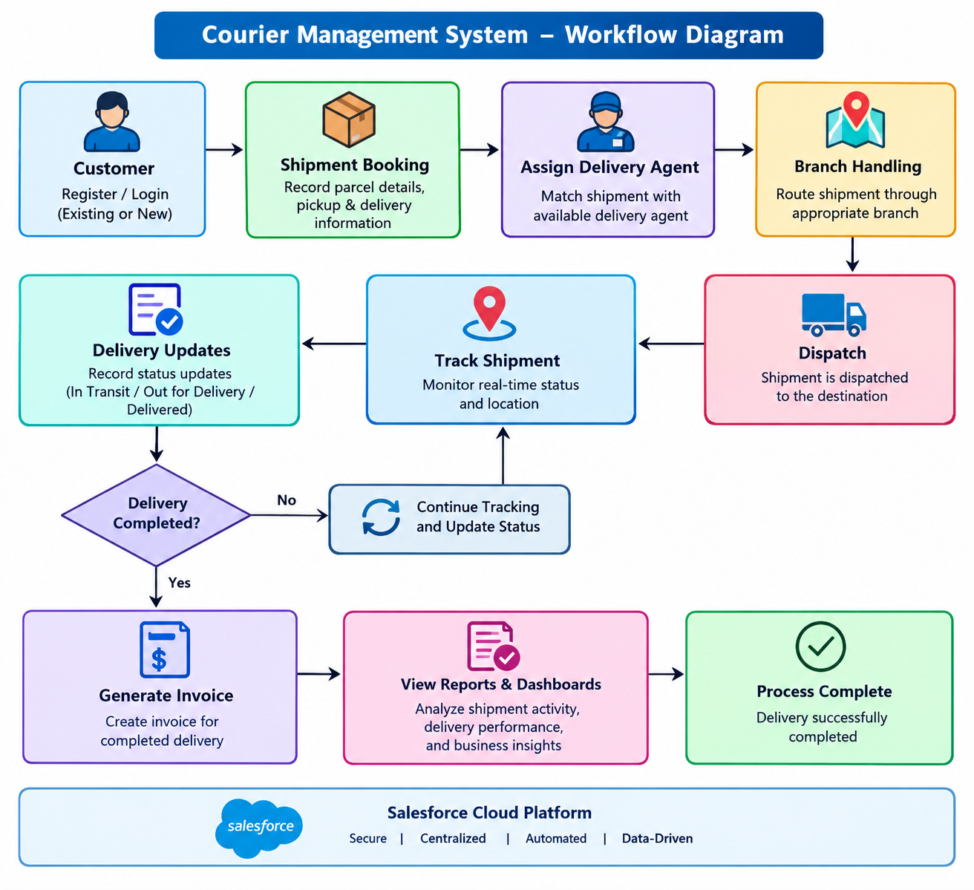

SUMMARY
The Courier Management System is a cloud-based logistics management application developed using Salesforce to simplify and improve the management of courier and delivery operations. The system provides a centralized platform for storing and managing information about customers, shipments, delivery agents, branches, delivery updates, and invoices in a structured and organized manner.
The application uses custom Salesforce objects such as Customer, Shipment, Delivery Agent, Branch, Delivery Update, and Invoice to maintain important courier-related records. Master-Detail and Lookup relationships are used to establish proper connections between related records and maintain data consistency. Custom fields and validation rules help ensure that accurate and complete information is entered into the system.
The system supports the complete shipment workflow, starting from shipment booking and delivery-agent assignment through dispatch, tracking, delivery updates, and completion. Delivery updates allow users to maintain the current status of shipments, while invoice records help manage billing information associated with completed shipments.
The system also provides reports and dashboards for monitoring and analyzing courier operations. Users can view information such as the number of shipments, shipment status, delivery progress, assigned delivery agents, branch activities, completed deliveries, and invoice details. These features make it easier to monitor courier operations and obtain useful information without depending on manual calculations or separate records.
The cloud-based nature of Salesforce allows courier information to be securely stored and accessed from different locations. The system reduces manual paperwork, minimizes data duplication and entry errors, and improves the efficiency of maintaining shipment and delivery records. Salesforce automation, validation, and security features further support consistent and reliable data management.
Overall, the Courier Management System demonstrates how Salesforce technology can be applied to the courier and logistics sector to transform traditional shipment record-keeping into a centralized and organized digital system. By combining structured data management, object relationships, validation, tracking, reports, dashboards, and cloud accessibility, the system supports efficient courier administration and provides users with accurate information for managing delivery operations.
SCREEN SHORTS
OBJECT:
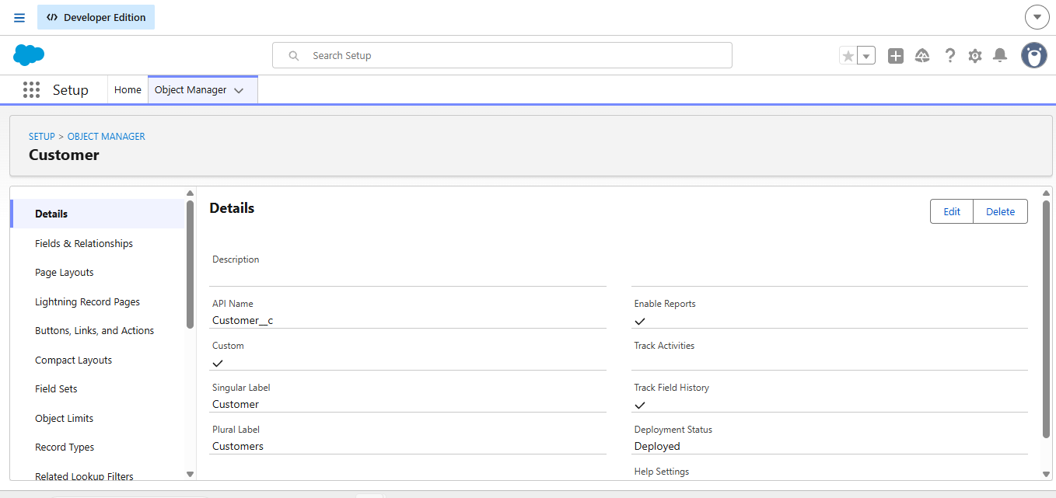

TABS
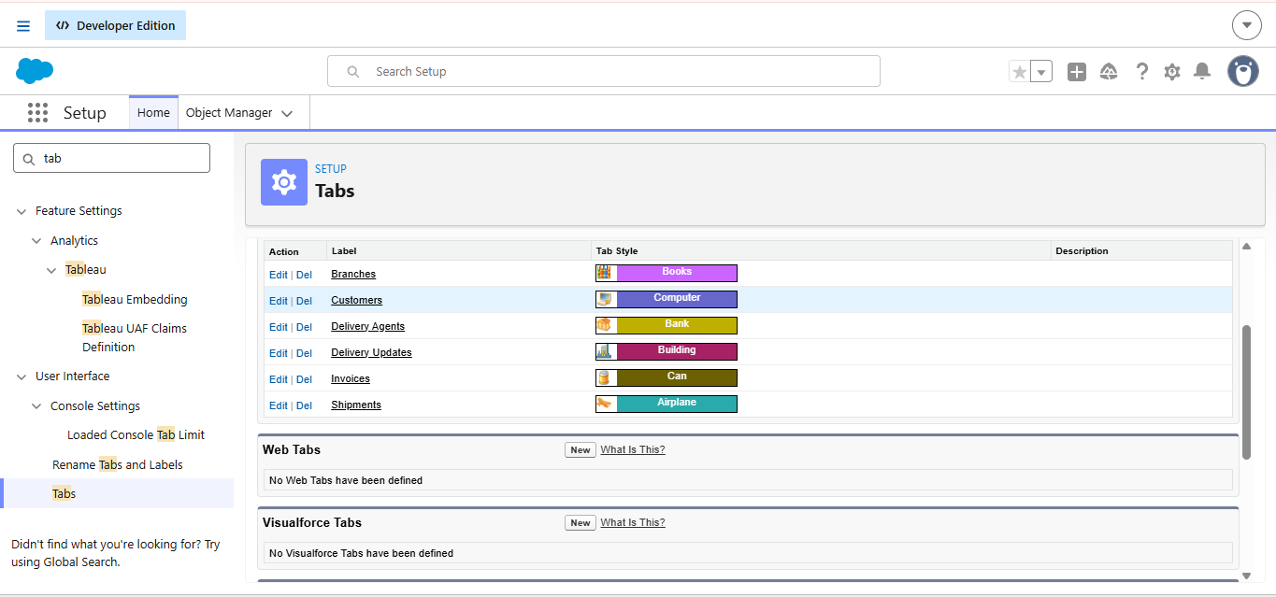
FIELDS AND RELATIONSHIPS
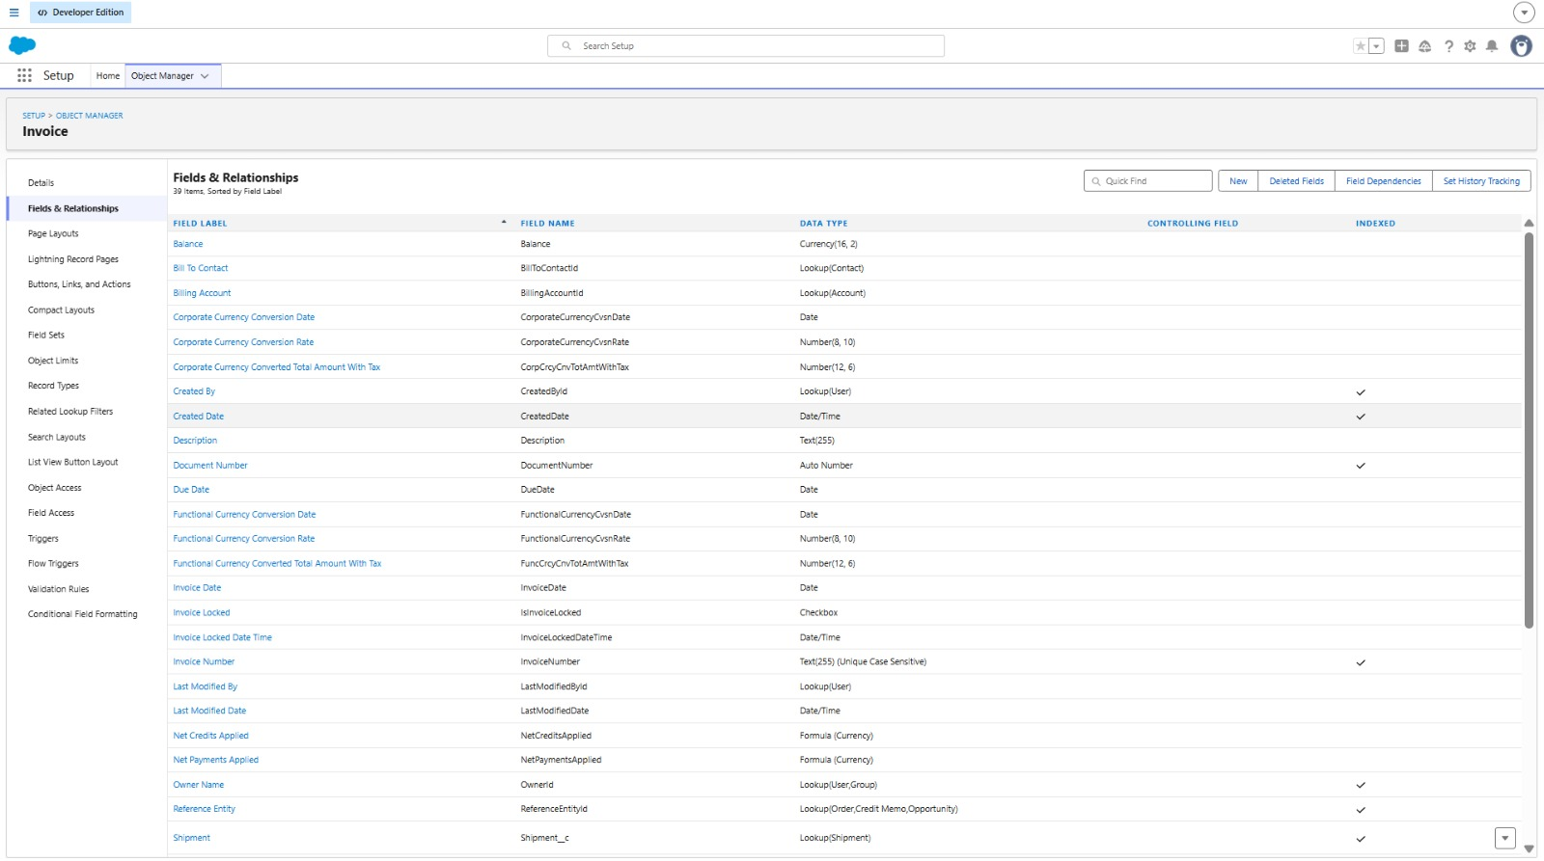

VALIDATION RULES
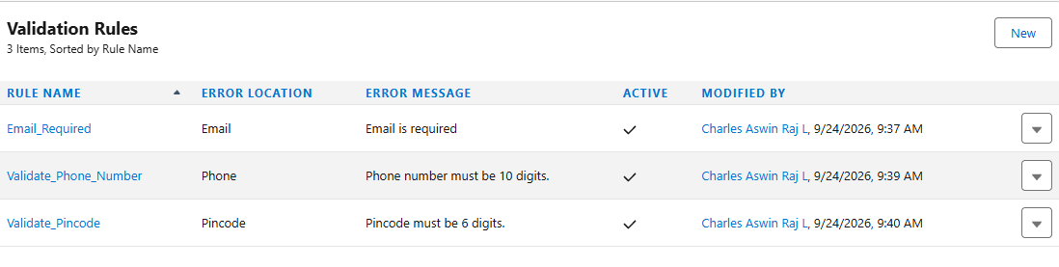

PAGE LAYOUTS
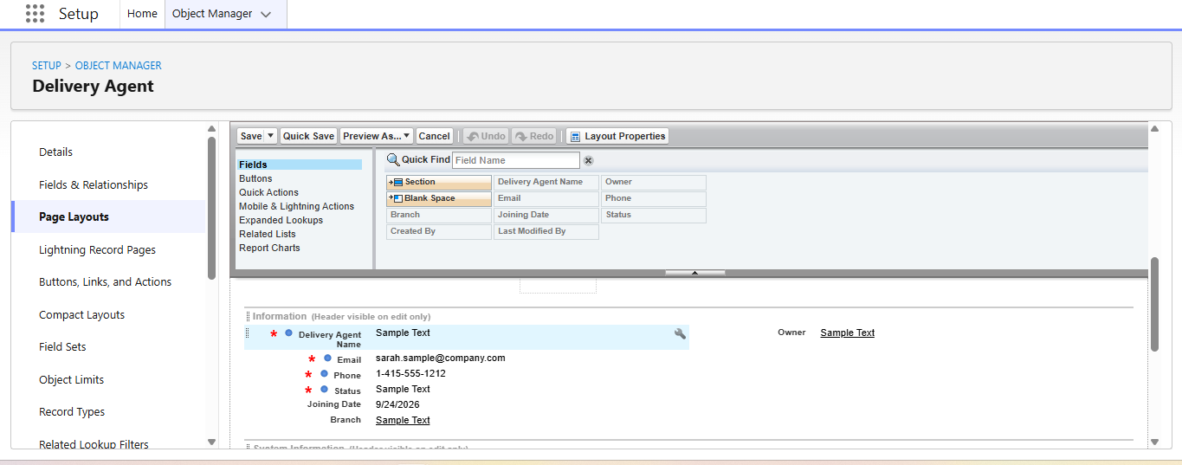

FLOWS
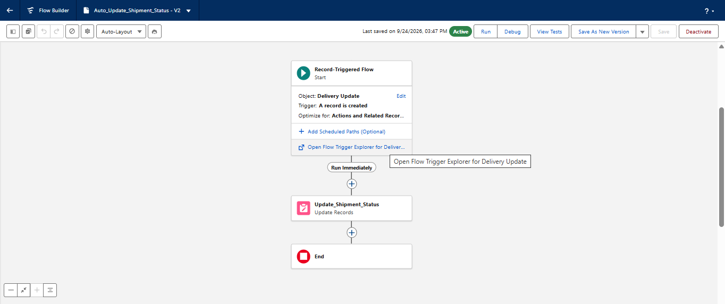

CONCLUSION
The Courier Management System successfully addresses the limitations of traditional methods used for managing courier and delivery-related information. By implementing the solution using Salesforce, the project provides a centralized platform for managing customers, shipments, delivery agents, branches, delivery updates, and invoices while improving data accuracy, organization, security, and accessibility.
The system provides a structured method of maintaining shipment and delivery records and establishing relationships between related information. The use of Master-Detail and Lookup relationships helps maintain data consistency, while validation rules reduce errors during data entry. Salesforce features such as automation and custom fields also reduce manual effort and simplify the management of courier operations.
The shipment workflow provides a systematic process for booking shipments, assigning delivery agents, handling branch operations, dispatching parcels, tracking shipments, updating delivery status, and completing deliveries. Delivery Update records help maintain the progress of each shipment, while Invoice records provide a structured method for managing billing information.
The use of reports and dashboards provides users with useful insights into shipment activities, delivery status, agent assignments, branch operations, completed deliveries, and invoice information. This makes it easier for courier administrators and delivery managers to monitor operations and access important information for planning and decision-making.
The Courier Management System also improves transparency and reduces dependency on paper-based records and disconnected spreadsheets. The cloud-based Salesforce platform provides centralized data storage, allowing authorized users to access courier information from different locations while maintaining appropriate security and access controls.
In conclusion, this project demonstrates how modern cloud-based technology such as Salesforce can be effectively applied to the courier and logistics sector. The Courier Management System improves operational efficiency, simplifies record maintenance, reduces manual errors, and supports organized management of shipment and delivery information.
The successful implementation of this system highlights the importance of integrating technology into courier operations. By combining centralized data management, object relationships, validation, automation, shipment tracking, reports, and dashboards, the system provides a foundation for smarter, more efficient, and technology-driven courier management in the future.

